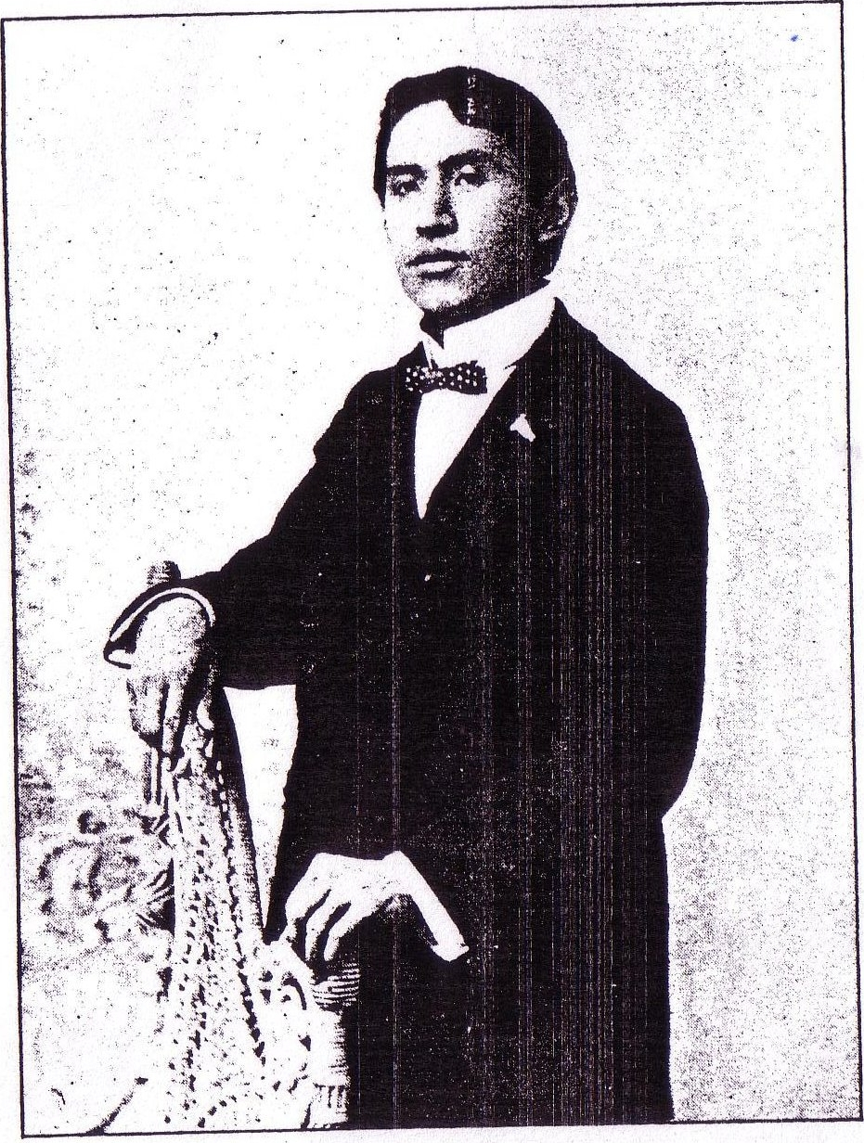
JOSEPH F. ADAMS.

