-lately there have been pushes to increase the minimum wage in both the state and federal levels, with has been an issue for years now especially for political candidates
-many would like to see the minimum wage increased in order to decrease poverty and to boost the economy
-unfortunately the effects of imposing a minimum wage are often not positive
-studies and statistics I have found show that in fact a increase in minimum wage will decrease employment opportunities, especially for entry level employees, and in particular cause problems for low-skilled employees.
-one study found that the majority of individuals who were earning minimum wage do not in fact live in families with low incomes, proving that this increase in minimum wage would not be affecting those in poverty. This same study showed that the majority of individuals living in poor families have wage rates higher than 7$ an hour (a proposed possibility for a new higher minimum wage) (almost 90% of all workers in one study earned above 7 $ an hour), and are living in poor families because they are not working full time, or because their family size is too large for their hourly rate to put them above the poverty line, not because they aren’t earning above the minimum wage. Once again the minimum wage would not be positively affecting those families in need.
-more statistics supporting this show that only 15% of benefits from the increase in minimum wage would go to families in poverty, while around 60% would be going to families earning almost twice the poverty line.
-much research has proved that a wage increase would be costing young African Americans, non-high school graduates, and teenagers their jobs. A 10% increase in minimum wage could cause up to four times more employment loss for employees without a high school diploma and African American young adults than it does for more educated and non-black employees.
-this 10% increase in minimum wage is also associated with a 0.9-1.1% decline in retail employment (which often includes many entry-level and low-skilled workers), and a 0.8-1.2% decline in small business employment. There would be about a 2.7-4.3% decline in teen employment in retail, and a 4.6-9% decline in teen employment in small businesses.
-there have been studies done also that predict what may happen with raises in state’s minimum wage, for example Missouri, where almost four-fifths of the benefits from this raise will go to families above the poverty line, and almost 30% of the benefits going to families with annual incomes over $60,000. Employees would then see the labor costs increasing approximately $44.4 million dollars a year, with a projected 1552 employees losing their job. Or in Arizona where some 70% of the benefits will reach only those above the poverty line, and an approximated 29% job loss for high school drop outs.
-Furthermore, when faced with the increase in labor costs that inevitably comes to the employer when they must pay for the minimum wage hike, often they will respond by hiring more skilled applicants, automated jobs, or cutting back on customer service. This causes, once again a decrease in entry level positions, and low-skilled jobs.
-I thought I would provide you all with some graphs to support the data I found:
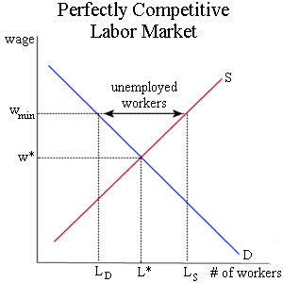

As shown from this graph, the one that is most commonly used to support that we should not increase the minimum wage, the Wmin (the wage at the new imposed minimum wage) would cause a decrease in labor demanded, causing an increase in unemployment, and a deadweight loss. It has also been shown that this increase in minimum wage can cause inflation, as employers have to pay more, causing an increase in prices, and therefore making the new higher minimum wage in actuality not much higher.

Then I also have two graphs here in support of the fact that the increase in minimum wage tends to negatively affect those without high school education (often leading to a loss of entry level jobs and low-skilled worker’s jobs).
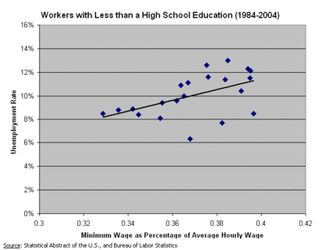
This graph shows the unemployment rate and minimum wage relative to the average wage for those workers who did not graduate high school. In general, there seems to be an increase in the unemployment rate.
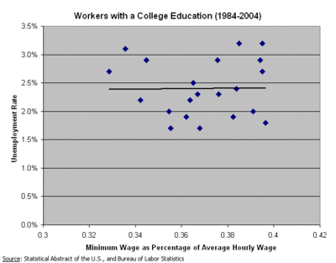
For workers with a college education, the minimum wage seems to not affect the unemployment rate.

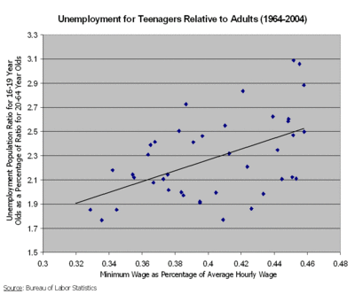
It seems the raise in minimum wage would have a much larger effect on teenagers rather than adults

And finally,
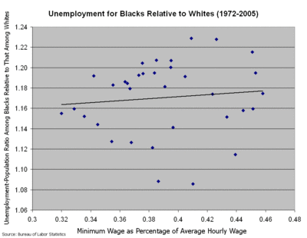
Data showing increases in minimum wage may be weakly associated with higher unemployment rates for blacks than whites.

-in conclusion, it seems that the increase in minimum wage that is supposed to help with the poverty problems, and with giving a fair wage to all employed in the US may in fact be further creating problems, because it is not target-efficient
-In accordance with all of this information, in a recent study, almost 77% of labor economists with the American Economics Association believe that a raise in minimum wage has a negative effect on employment.
-If we are losing entry level positions and low skilled workers, they will not have the ability to become skilled workers in higher-level positions in the future.
-And I would like to end with a quote from Mike Flynn who is the Director of Legislative Affairs at the Employment Policies Institute:

“Proponents of the minimum wage hikes contend that the attendant job loss is minimal and worth it, but they’re ignoring the fact that it is almost exclusively low-skilled adults who lose their job. Minimum wage hikes end up hurting the very people they are intended to help by jeopardizing the jobs of those most in need of assistance”

Sites used:
http://www.swlearning.com/economics/policy_debates/increase_minimum.html
http://www.epionline.org
http://en.wikipedia.org/wiki/Living_wage
http://en.wikipedia.org/wiki/Minimum_wage

